**ITEC 3200**

**Student Worksheet**

**Student Name:**

Please complete the worksheet according to the instructions provided in class. Please ensure to upload the completed worksheet at the end of the class to the assignment folder in d2l with today’s date so you earn points for class assignments

1. Think about the database that you have proposed in for your class project and identify one business rule that you might establish

The customer must have a valid credit or debit card in order to make a purchase.

1. Refer to the slide to answer A-D below

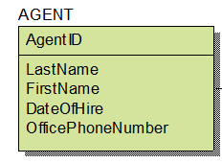a

1. Agent
2. LastName, FirstName, DateOfHire, OfficePhoneNumber
3. AgentID
4. Composite? Yes
5. Refer to the slide to work on answer A and B



A. Many to Many

B. One to One

1. Refer to the slide to work on answer A and B

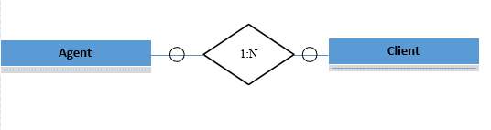

A. One to Many

B. Mandatory to Zero